Final Project

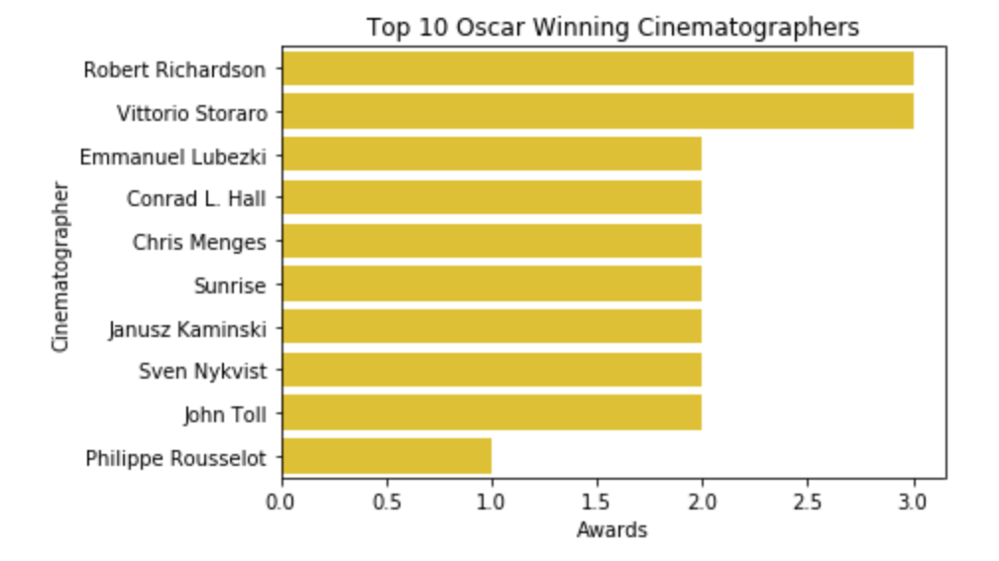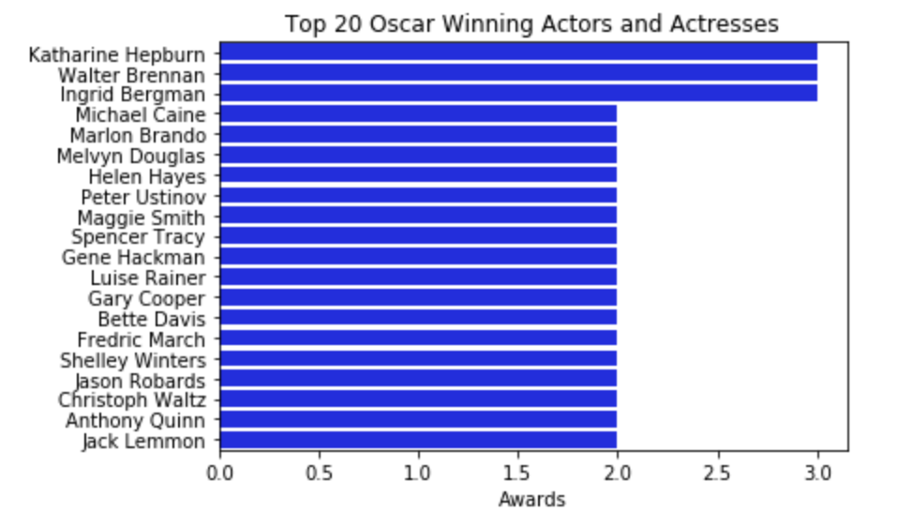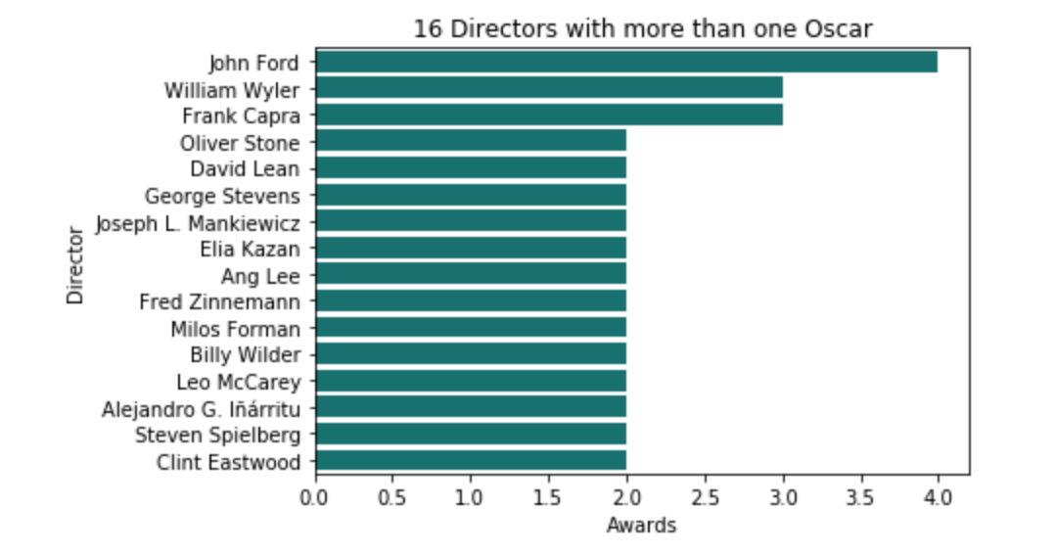

For my data visualizations, I wanted to look at diversity in the film industry. As a media production major, I aspire to work in film as a cinematographer. Looking at the cataloged history of the Oscars made this project interesting for me. I took a look at three specific sets of data. For the first, I wanted to see the Cinematographers with the most Oscar wins. For the second visualization, I took a look at the top performing actors and actresses, in terms of Oscar wins. In the third visualization, I found the sixteen Directors that have at least two Oscars for Directing. In designing which sets of data I wanted to visualize, I took into accounted for three major points of Film: cinematography, performance, and direction. In the department of Cinematography, six of the ten best Cinematographers come from an Immigrant background. These Cinematographers include, Vittorio Storaro, Emmanuel Lubezki, Chris Menges, Janusz Kamiński, Sven Nykvist, Philippe Rousselet. With the actors/actresses, there are three thespians that have three Oscar awards: Katherine Hepburn, Walter Brennan, and Ingrid Bergman. As it turns out, eight of the sixteen directors come from sort of immigrant background, including Ang Lee, Alejandro G. Inarritu, Billy Wilder, Milos Forman, Elia Kazan, Fred Zinneman, David Lean and Frank Capra. John Ford is the only Director to win four Oscars for Directing. Overall, it was very interesting delving into this data set. I found that in the elite of the Film industry, many people from immigrant backgrounds find success. I personally look to Directors like Ang Lee, Alejandro g. Innaritu and cinematographer Emmanuel Lubezki for breaking many boundaries of race through their storytelling and their methods. As for the actors and actresses, that’s where the diversity is very heavily lacking.

<http://www.sandiegouniontribune.com/sdut-what-some-oscar-winners-had-to-say-about-diversity-2016feb29-story.html>

Words from Alejandro G. Inarritu, Emmanuel Lubezki, and Ang Lee over the #OscarsSoWhite controversy.

<https://www.newyorker.com/culture/cultural-comment/is-the-era-of-oscarssowhite-over>

More present look at the Oscars of 2015 a few years later with added diversity in Television and Film.

<https://www.washingtonpost.com/graphics/2018/entertainment/diversity-in-films/?utm_term=.be77aa1125ec>

Statistical break down the History of the Oscars and the fragmented disproportion of minorities in the Oscars.

<http://time.com/4645315/oscar-nominations-2017-diversity/>

Documentation of Oscar nominations and wins for people of color and minorities, specifically the African American community as well as female directors.

<https://www.economist.com/blogs/prospero/2016/01/film-and-race>

Infographic showing the skew of race in the film industry.